Pratibha Jha 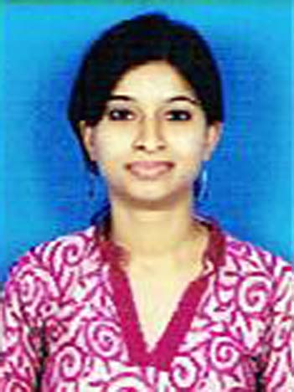

R-20/3,Saurabh vihar,Hari nagar part 1

Badarpur, New Delhi-44.

Tel. Number- 7503804603, 8802499240 Email[pratibha.educator@gmail.com](mailto:pratibha.educator@gmail.com)

Language Teacher SANSKRIT/ HINDI

Teaching is not like filling bucket its like kindling a lamp, I am very dedicated to students and truly believe on transforming of knowledge.

Professional experience gained within varied practical and development roles, mainly within modern support. Believing a mature, constructive and eclectic teaching approach and effective working relationships between staff, students and parents are crucial to a responsive student attitude, a successful learning environment and meeting the needs of children and school mandates. Now looking to make a continued significant contribution for a school in preferably as a classroom teacher, a language teacher or a position of similar responsibility.

PROFESSIONAL DEVELOPMENT

Currently working with THE SHRI RAM MILLENIUM SCHOOL( ICSE), Noida Branch.

|  |
| --- |
| Ducat **EDUCATION** |

|  |  |  |  |
| --- | --- | --- | --- |
| CBSE(Class 10) | 2004 | CBSE | 66.5% |
| CBSE(Class XII) | 2006 | CBSE | 74.2% |
| B.A. Sanskrit Hons. | 2006-2009 | LADY SRI RAM COLLEGE FOR WOMEN, D.U | 63.63% |
| B.Ed | 2010 | RASHTRIYA SANSKRIT SANSTHAN, DELHI | 76 % |
| CTET | 2011 | CBSE | 70% |
| M.A (HINDI) | 2013-2015 | IGNOU | Pursuing final year |

PROFESSIONAL EXPERIENCE AND SIGNIFICANT ACHIVEMENTS

|  |
| --- |
| **ACADEMIC PROJECTS** |

* Project 1.ARCHAEOLOGY AND EPIGRAPHY
* Project 2: Organic farming and earth’s democracy at St. beeds Collge, Shimla.

|  |
| --- |
| **ACADEMIC ACHIEVEMENTS AND AWARDS** |

* Secured Good academic position.
* NCC ‘B’ CERTIFICATE 2008.
* NCC ‘C’ CERTIFICATE 2009.
* Awarded G.L.BANSAL. SCHOLARSHIP
* Best article prize in LSR College Magzine 2009-10.
* Received Prize on Describing Surpnakha character in Ramayna Inter university competition.

|  |
| --- |
| **POSITIONS OF RESPONSIBILITY** |

* Representative sexual harassment committee of the college.

*Co-coordinator of REACH society-2008.*

* Learned Spoken Sanskrit from Rashtriya Sanskrit Sansthan, Delhi.
* I have been part of National Sports Organization in Yoga for 3 yrs.
* Participated in Inter-college debate organized by NSS in 2007
* Participated in run in 2007 for spreading awareness regarding the education of girl child.
* Worked with REACH and HIVE societies of the college in 2007-08
* **I taught class 3,4,5,6,7 for Hindi and 6,7,8,9,10 for Sanskrit.**
* **Trip coordinator for 2013-14.( The shri ram millennium School)**
* House Mistress for 2013-14.
* Conducted Hindi and Sanskrit based Class Assembly.

|  |
| --- |
| **OTHER INFORMATION** |

* Basic computer knowledge in Microsoft Office: Excel, PowerPoint, Hindi Typing.
* Current salary- 6th pay scale grade.( 32943rs Monthly)
* Worked with A.V.N.SR.SEC.SCHOOL,Sec-19 (july,2010 to nov, 2010)
* Worked with THE HERITAGE SCHOOL,VASANTKUNJ BRANCH(Dec,2010 to March, 2012)
* **Currently working with THE SHRI RAM MILLENIUM SCHOOL( ICSE), Noida Branch.**